**Jerome Pitogo de Leon | 35-166337 | Astronomy Dept.**

**HW2: Detecting planets via radial velocity variations**

1. Joe Spectrograph studies the star Gliese 33 = HD 4628. He has heard that an exoplanet has been discovered around this star.
   1. What is the value of vsys for this star?

Nidever et al. 2002 observed HD 4628 on t= 9262-2440000 (JD) and measured RV(t) = ***v*sys  = -10,230 m/s**.

* 1. What is the mass of this star?

Ghezzi et al. 2010 estimated the mass of HD 4628 to be **M = 0.7 M_sun** using a grid of evolutionary tracks.

* 1. Make a graph showing the radial velocity predicted by this formula over three consecutive cycles

Using the ephemeris equation of the star

RV(*t*) = *K* cos (2𝝅 (*t*-*T*)/*P*) + *v*sys

given *T* = 2457083.15992 (Julian Date), P = 5.2616 (period in days), *K* = 69 m/s, and *v*sys  = -10,230 m/s, at *t*=[0,3\**T*] days, yields the following graph.

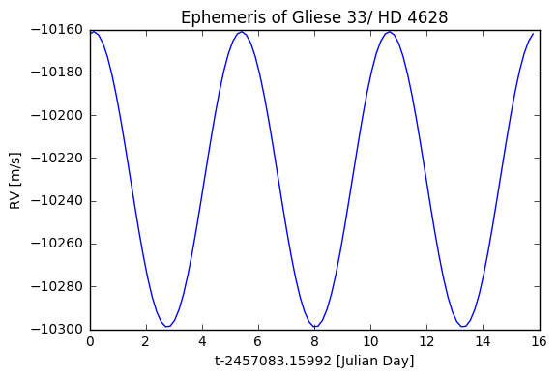

Fig. 1.1. Predicted ephemeris of HD 4628 over 3 periods (period=5.2616 d).

Joe uses his telescope, in Rochester, NY, to measure the spectrum of this star on the following nights: Oct 1, 2, 7, 9, 12, all in 2015. On each night, he measures the spectrum three times: at 10 PM, midnight, and 2 AM, each time with an exposure time of 10 minutes. He calibrates his spectrum against a neon-helium lamp inside the dome each time.

* 1. **Bonus!** Make a graph showing the radial velocities Joe will measure from his spectra, relative to the lamp in the dome.

The dates corresponds to [2457297, 2457298, 2457303, 2457305, 2457308] JD each with [0.25, 0.4166667, 0.3333333] offset corresponding to three different times of observation done during that day. These observations correspond to the red data points in Fig. 1.2.

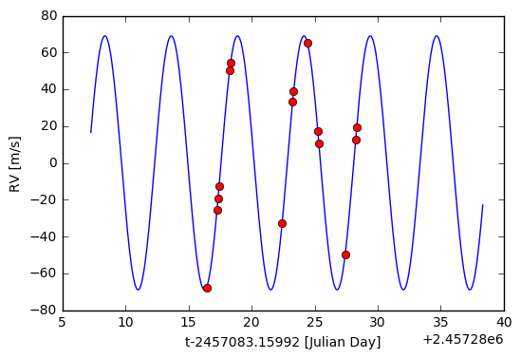

Fig. 1. 2. Predicted absolute RV measurements of the HD 4628 over 5 days with 3 measurements per day.

* 1. What is the distance of this planet from its host star?
  2. What is the mass of this planet?

Joe figures out that he should use standard stars to remove most of the radial velocity variations due to the Earth's rotation and orbital motion. He modifies his procedures and now produces nice tables of radial velocities which show only the change due to the star's own motion.

1. Over a period of several years, Joe measures the radial velocity of one particular star. He sees pretty clear evidence for an exoplanet.
   1. What is the period of variations in this star's radial velocities?

To derive the period, let’s first inspect the dataset. Not all data points are used because some data (shown in red in Fig. 2.1) produces noisy periodogram. As seen in right panel of Fig. 2.1, the red data points have much smaller cadence than the blue ones. The red data points have baseline of less than 1 period. This will produce low frequency noise in the periodogram and hence they are masked. Note that error bars are much smaller than the data points.

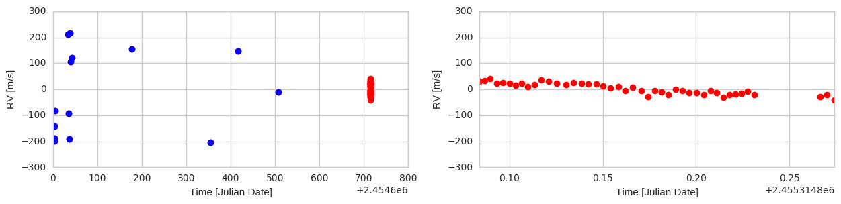

Fig. 2.1. RV observation of full data set 1. The blue and red markers correspond to the filtered and masked data points.

Periodogram is useful to derive the period. This is shown in Fig. 2.2 using only the blue data points in Fig. 2.1.

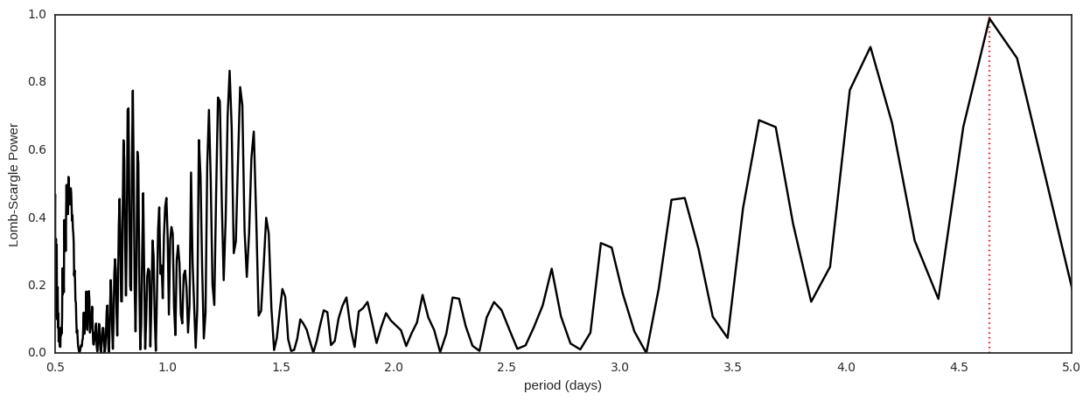

Fig. 2.2. Periodogram of the star using filtered data points.

The derived period is **4.64 days**. Period and other fitting parameters can be optimized using some optimization algorithm such as Nelder-Mead. Fig. 2.3 shows the result of optimization which produces a best-fit curve. The optimum period in this case is **P=4.7 days**. The right panel of Fig. 2.3 is the histogram of the squared errors.

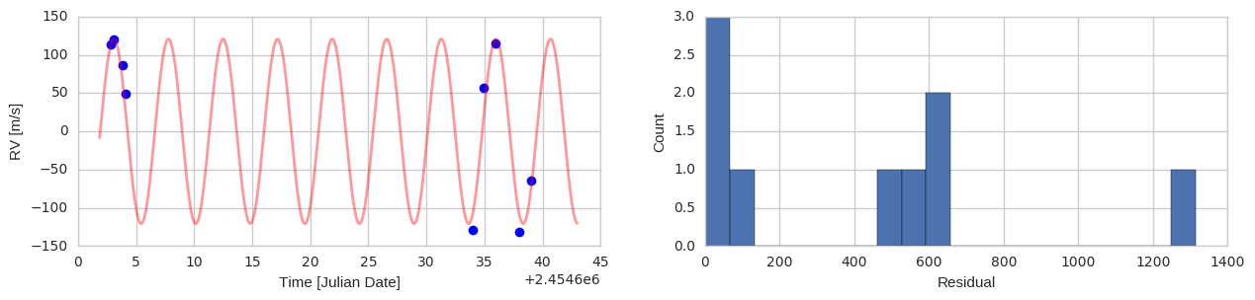

Fig. 2.3. Best fit curve superposed to the filtered data points and its resulting histrogram of residuals.

* 1. Assuming that this is a Sun-like star, what is the orbital radius and mass of the planet?

Assuming that M_planet << M_star, we can use Kepler’s 3rd law to estimate the orbital radius. Using M_star=0.7*M_sun, P=4.7 * 60 * 60 * 24 s, yield

$a=(GM_{star}P^{2}/{4π}^{2})^{1/3} ≅ 0.056$ AU

To compute the M_planet, we compute first the v_planet and input it to the conservation of momentum equation:

v_planet = 2*np.pi*a/(P*60*60*24)

Thus,

* 1. **Bonus!** This is a real exoplanet. Which one?

Looking up in the NexSci archive database, **HD 103774** seem to match the derived values.

3. Joe finds another star with RV variations. These are less obvious.

* 1. What is the period of variations in this star's radial velocities?

If we subdivide the data set based on various epochs of observation and zoom in, we could discover a distinct (skewed sinusoidal) structure in the RV profile. Periodograms were obtained for each epochs or clumps of dataset and the derived periods are almost identical. That is, period is about **8.2 days**. Fig. 3.2 shows the periodogram obtained using only earlier epoch observation (i.e. blue data points. This dataset particularly shows stronger harmonics than that produced using only red data points. Again, the error bars are much smaller than the data points.

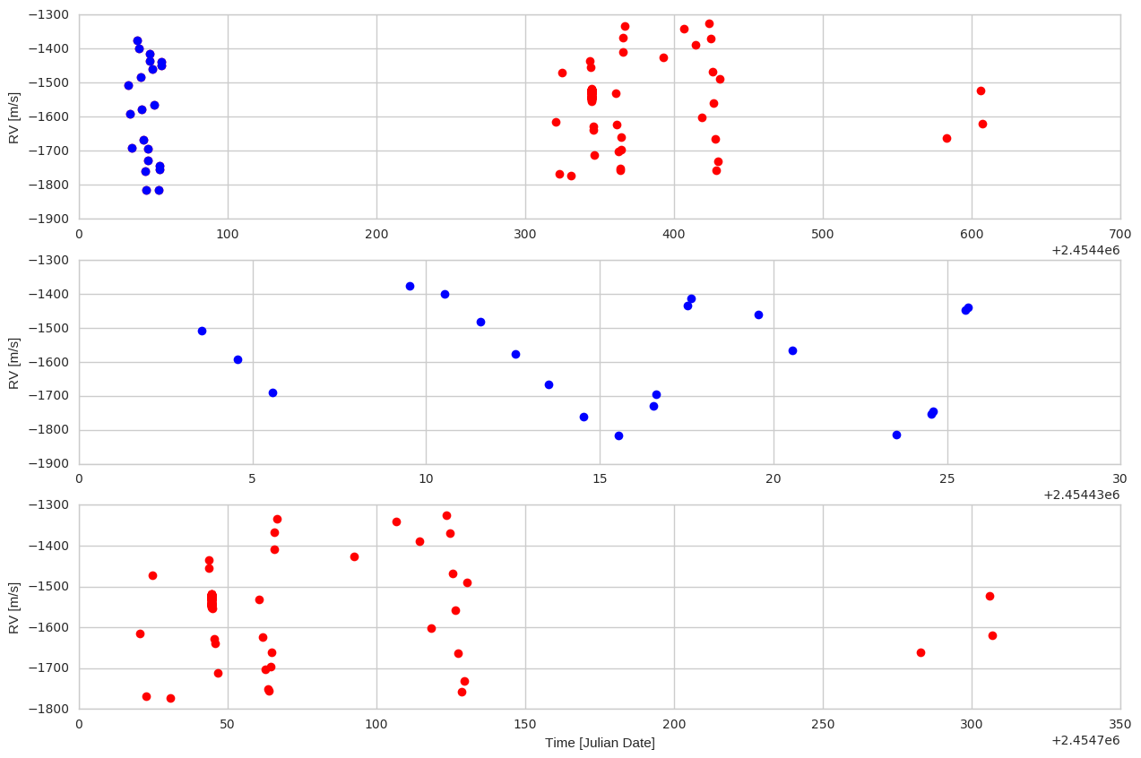

Fig. 3.1. Top: Full data set 2. Middle: Zoomed-in view of the left portion of the Top. Bottom: right portion of the Top.

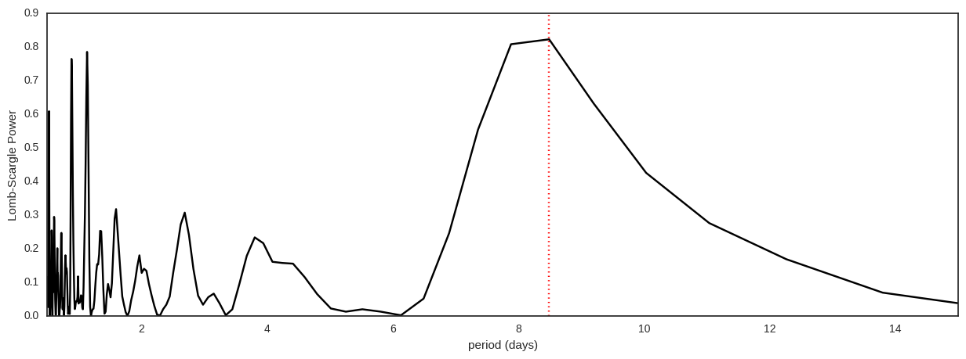

Fig. 3.2. Periodogram produced using earlier epoch (blue data points) observation.

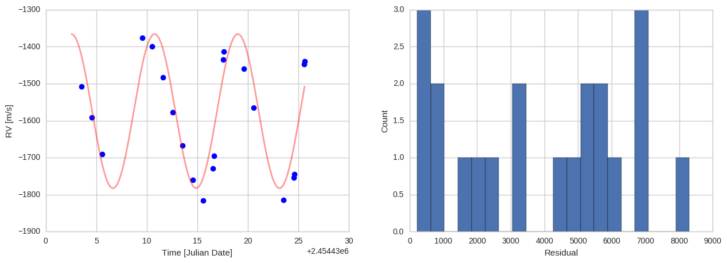

Fig. 3.3. Best fit curve superposed to the filtered data points and its resulting histrogram of residuals.

* 1. Assuming that this is a Sun-like star, what is the orbital radius and mass of the planet?

Assuming that M_planet << M_star, we can use Kepler’s 3rd law to estimate the orbital radius. Using M_star=0.7*M_sun, P=8.2 * 60 * 60 * 24 s, yield

$a=(GM_{star}P^{2}/{4π}^{2})^{1/3} ≅ 0.0798$ AU

To compute the M_planet, we compute first the v_planet and input it to the conservation of momentum equation:

v_planet = 2*np.pi*a/(P*60*60*24)

Thus,

* 1. **Bonus!** This is a real exoplanet. Which one?

Looking up in the NexSci archive database, **HIP 572574** seem to match the derived values.

Looking up on the derived values in the NexSci archive database,

**4. Bonus!** Joe thinks that maybe, just maybe, there might a signal in the measurements of another star. He's not sure. What do you think?

Given the dataset which seems pretty noisy to me with no apparent periodicity, I can ignorantly adapt the period obtained from the periodogram which is about **8.8 days**. This gives a planet’s orbit of **a=0.0834 AU** and a planet mass of about **2.23 M_Earth**. If this is a real planet, perhaps this corresponds to **Kepler 422**.

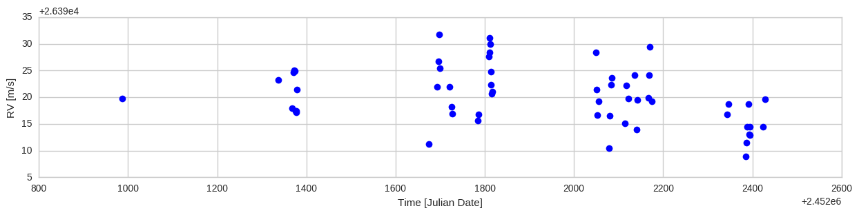

Fig. 4.1. Full data set 4.

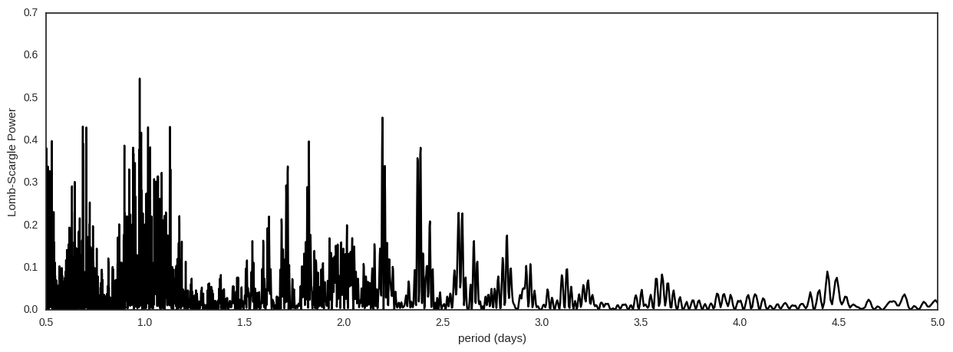

Fig. 4.2. Periodogram of data set 4.